**Spring Boot**

* Spring Boot is an Another source of framework built on the basis of Spring Framework
* Now its part of VMware 2014
* Boot refers the concepts of rapidly or fast handling applications because of Autoconfiguration and setups
* Spring boot makes building spring application easier and faster

**Spring boot core principle**

1. Opinionated default🡪when we create new project that time he provides dependencies project structure Application properties
2. Convention over configuration🡪it means it provides conventions e.g. using annotation like @RestControllerfor creating restful Apis ,@service for layers
3. Auto-Configuration🡪setting up components and Settings automatically based on project dependencies
4. Embedded Servers🡪Already servers embedded in SpringBoot

Use Of Spring Boot

* Web Application
* Restful web Services
* Microservices
* Batch processing
* Integration with other technologies like front end
* Testing
* Monitoring and management Spring

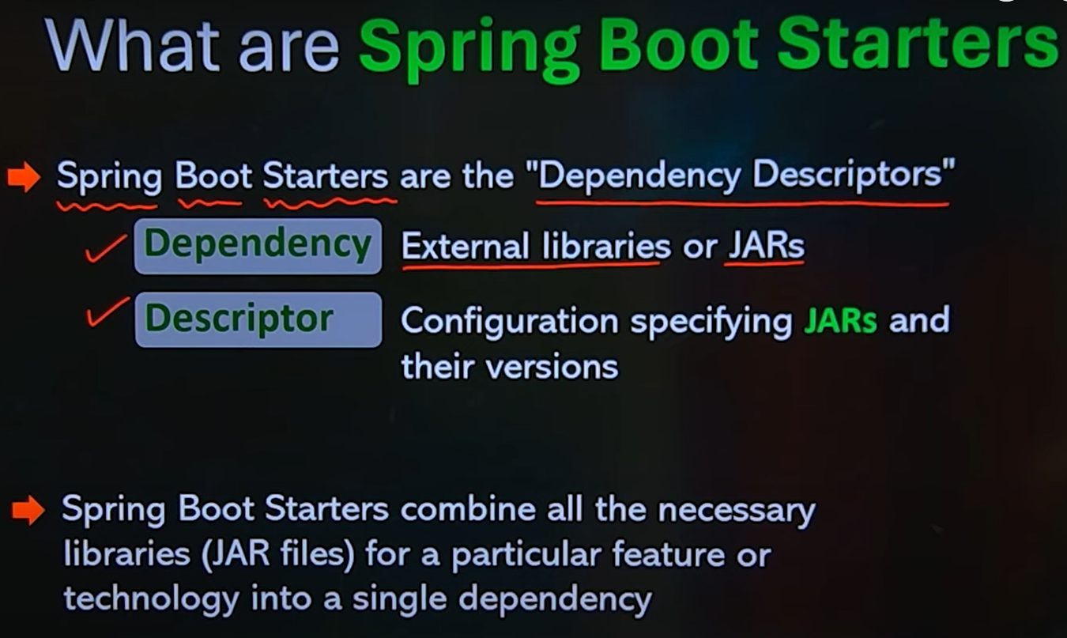

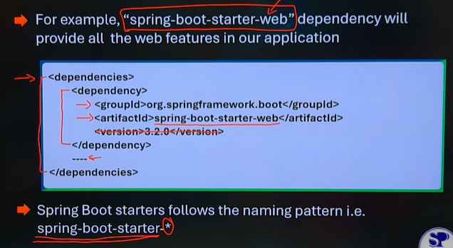

**Spring Boot Stater web🡪all jar files are added in this single dependacy**

**Create project**

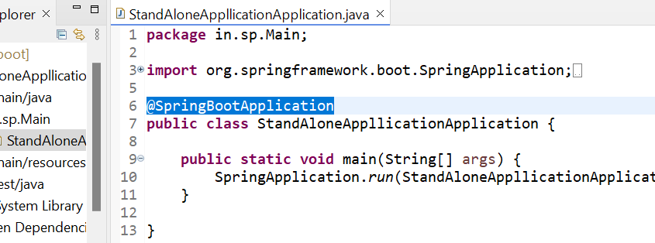**Standalone application🡪**

**@springBootApplication 🡪**Anoatation is for Auto configuration of all and its combination of

* @ configure 🡪bean configuartion
* @componentScan🡪to scan specified packages and its subpackages
* @EnableAutoConfiguration🡪it automatically configured Spring application based on its dependencies and content of Class Path
* Its entry point

**SpringApplication.run() 🡪run method do - application initialize- context configure, beans load and scan then register Automatically - start server ,all task run method will execute**

**Note-when you see in xml file dependency name is “Spring boot Starter” means its standalone**

**Application.properties 🡪we can add configu**ration

**Create web Application**🡪 when you see in dependency like “Spring Starter web” means its web application

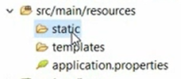**Static🡪**in this resources Static folder contains static web resources such as html, CSS, js, image, and assets

**Templates🡪**its commonly used to store dynamic web pages or templates

**Application. Properties file🡪**we provide configuration settings for various aspects of SB application e.g. database setting, server port.

Defines the class My Controller that will handle incoming requests

@Controller: can handle web requests

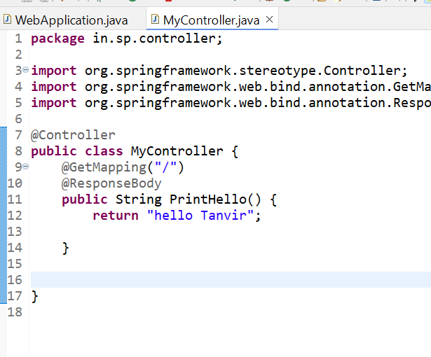@GetMapping: Maps HTTP GET requests to a method

@ResponseBody tells Spring to return the method's result as raw content (like plain text like Hello Tanvir)

This annotation maps the root URL (/) to the Print Hello() method.

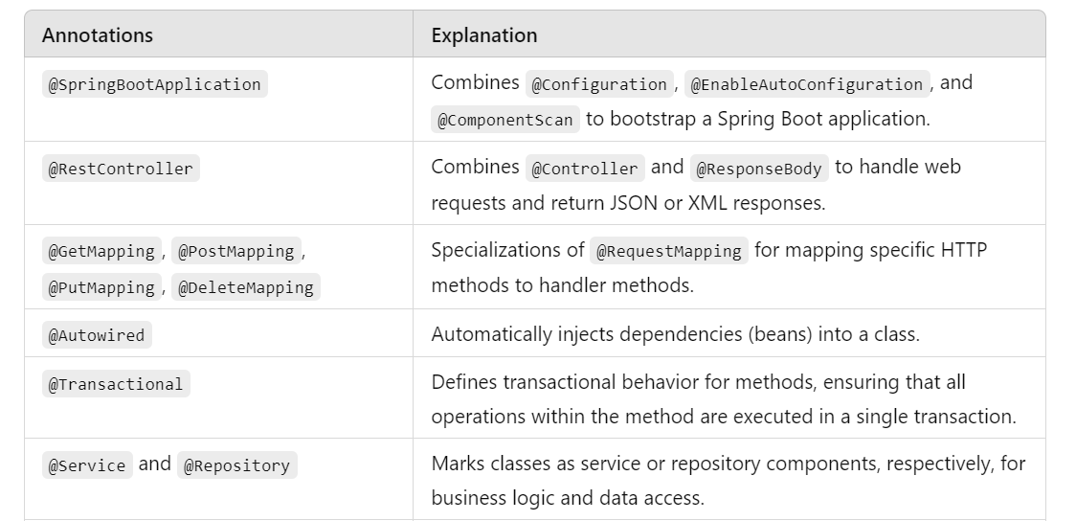**Annotations🡪**

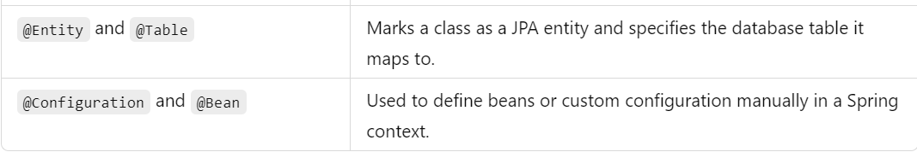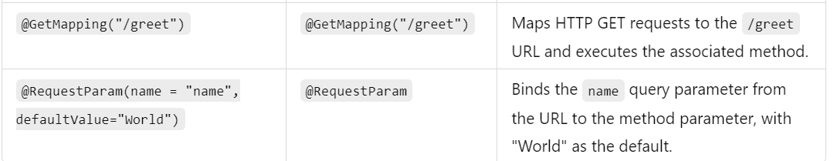

**Note: *Spring intalizr 🡪this is web application to develop project manually in website***

• **Automatic Configuration**: When you create a Spring Boot application with the @SpringBootApplication annotation, Spring Boot automatically sets up the Dispatcher Servlet for you. You don't need to define it manually in your web.xml file, as you would in traditional Spring applications.

• **Request Handling**: The Dispatcher Servlet in Spring Boot acts as the front controller, handling all incoming HTTP requests.

@SpringBootApplication scan only subpackages and own package

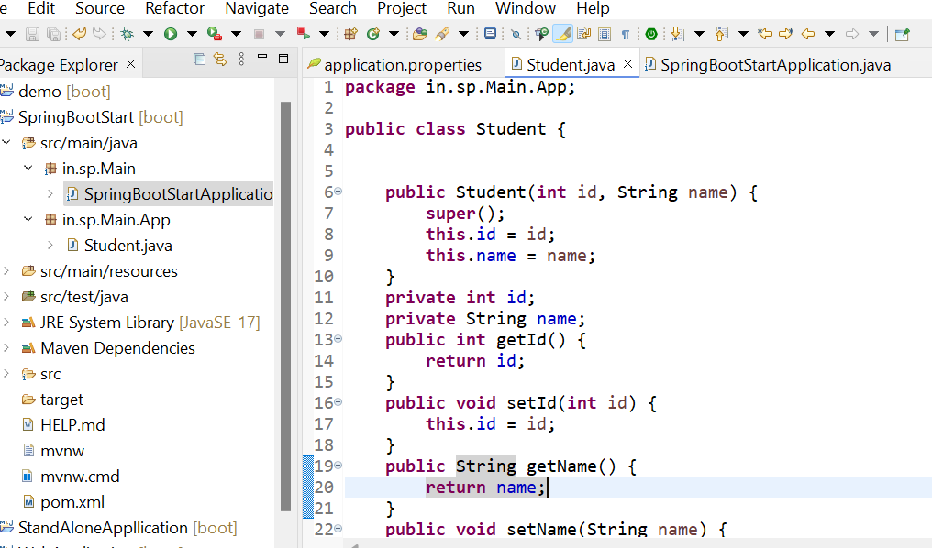

This is main Student class and we create bean using different scenario like below

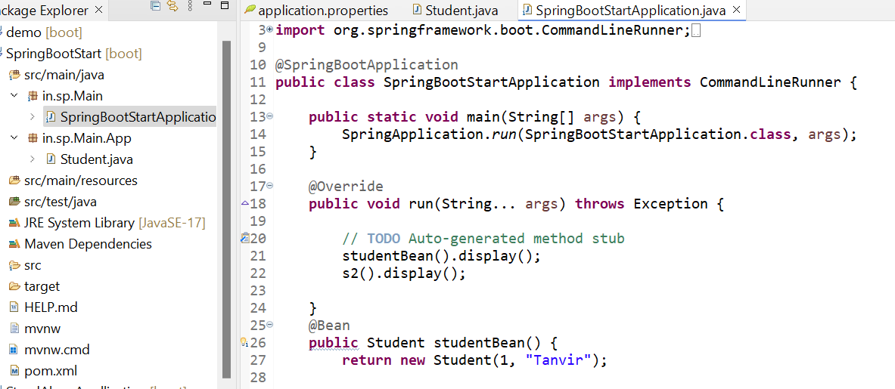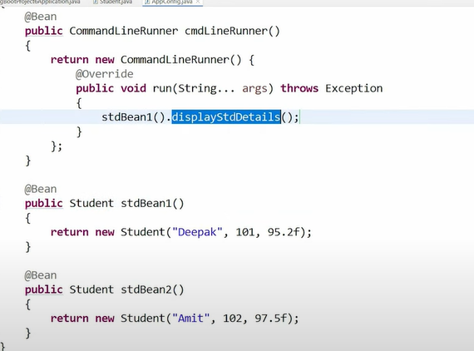

In both way left side and in right image we can create bean class

But in first image code will be neat and clean

And in right code and main method are in same so it looks very bad

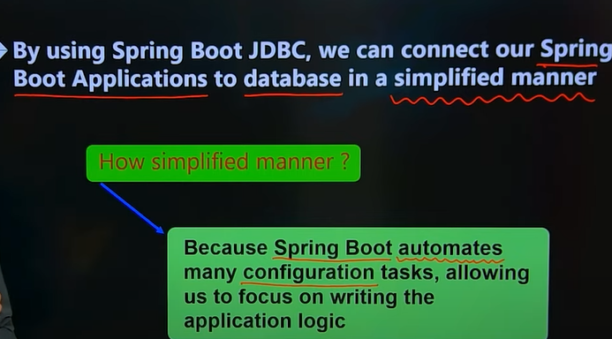

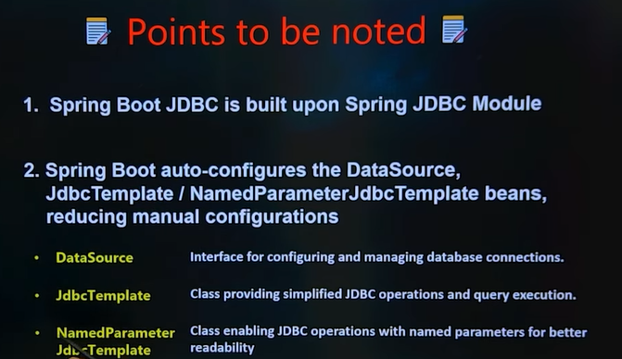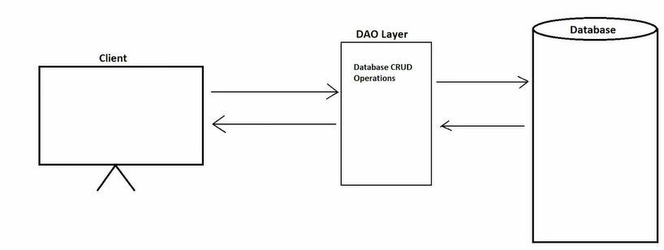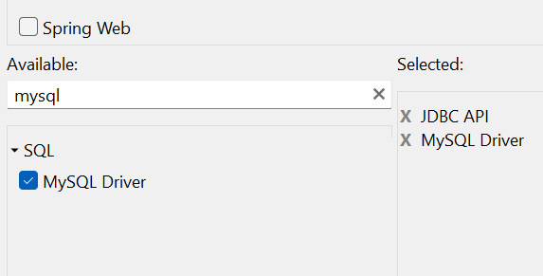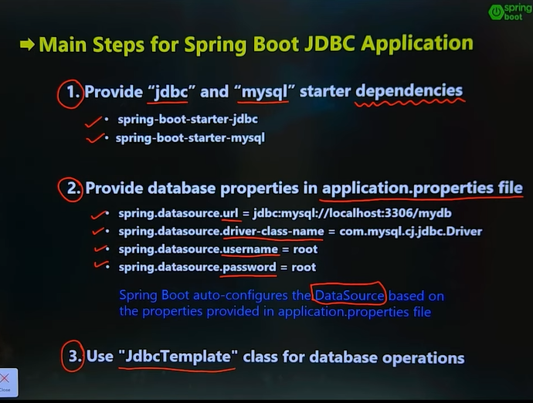

The **DAO (Data Access Object) layer** is responsible for interacting with the database by providing CRUD operations (Create, Read, Update, Delete) in a Spring application.

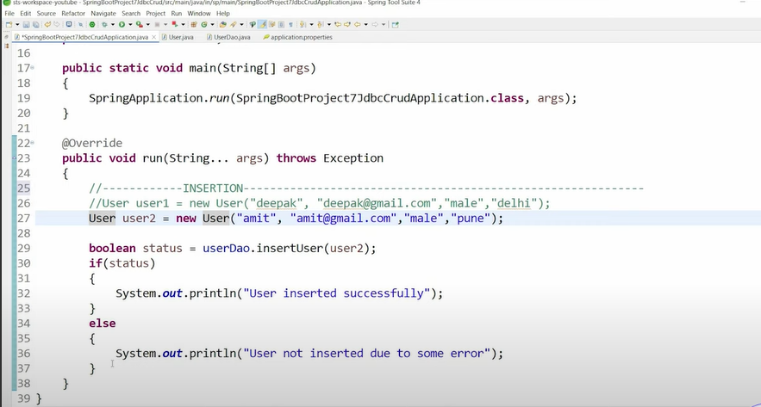

**What is hibernate🡪**

**This is framework I.e. ORM tool**

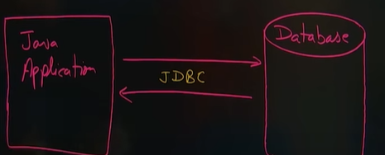**We can interact with database easily**

**If we have jdbc then why we need hibernate?**

**🡪**in jdbc we should add queries by own but it will be manually in hibernate

Java code+Sql queries we should add in jdbc But in hibernate no need Automatically backend will add.

**What is ORM ?**

->Object relational mapping (java object mapping with relational database)

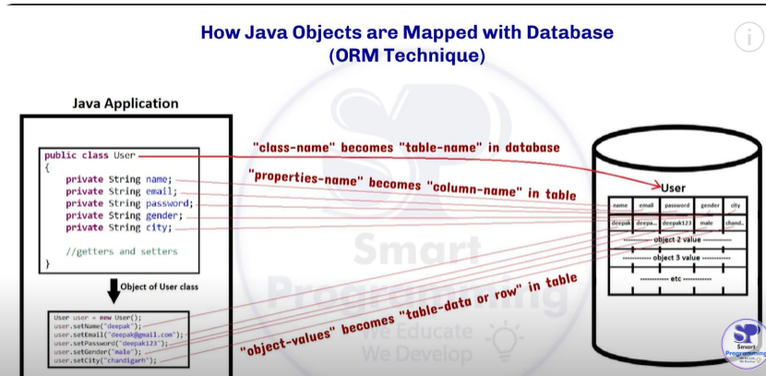

* **Map object and relational database in such way that class name and database table name mapped**
* **Each data in class directly mapped to columns in table**

**ORM tools 🡪1.Hibernate**

**2.JPA(java persistence API) etc.**

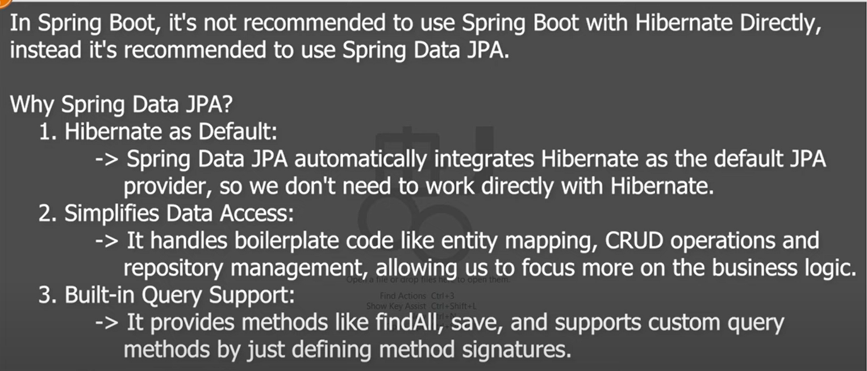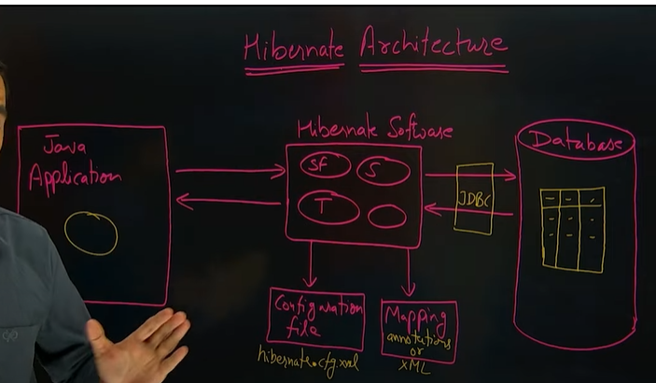**Architecture of hibernate🡪**

**What is API(Application Programming Interface) use,standard external, how it works and real world example.**

* **Definition-**Api is piece of code contains classes interfaces and method is used
* Its also provide documentation also provides rules regulation, protocols
* How to use API data all are define in API documentation

**Use Of API🡪**

* Api is used to perform Specific task efficiently
* Using API We can communicate(data Sharing) with multiple applications
* Phonpay communicate with Flipkart through API

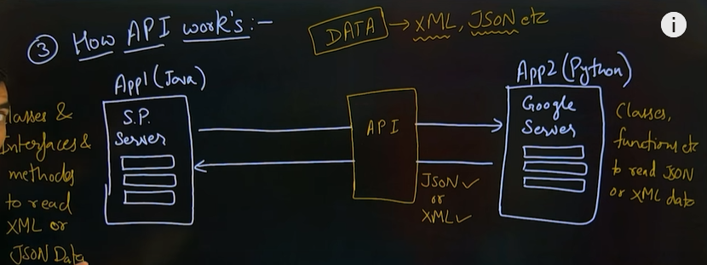

* Using External API we can connect or share data
* Data share in xml or Json format
* In java technology already developed classes function methods to read data

**Realtime Example🡪restaurant application**

**Web application made for zepto**

* + 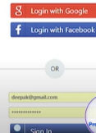Register logging //for authentication(we can add google and Facebook API)
  + List of food
  + Select food pay //API embed payment gateway like ppay
  + Track order //Api embedded for google map
  + Delivery
  + Useful for us we no need to write manually codes for payment ,authentication, profile creation

If person who don’t have knowledge of development 🡪restaurant owner he directly connect with Zomato and he give him his API for food upload rather than track order delivery and all he doesn’t care about this all responsibly of Zomato

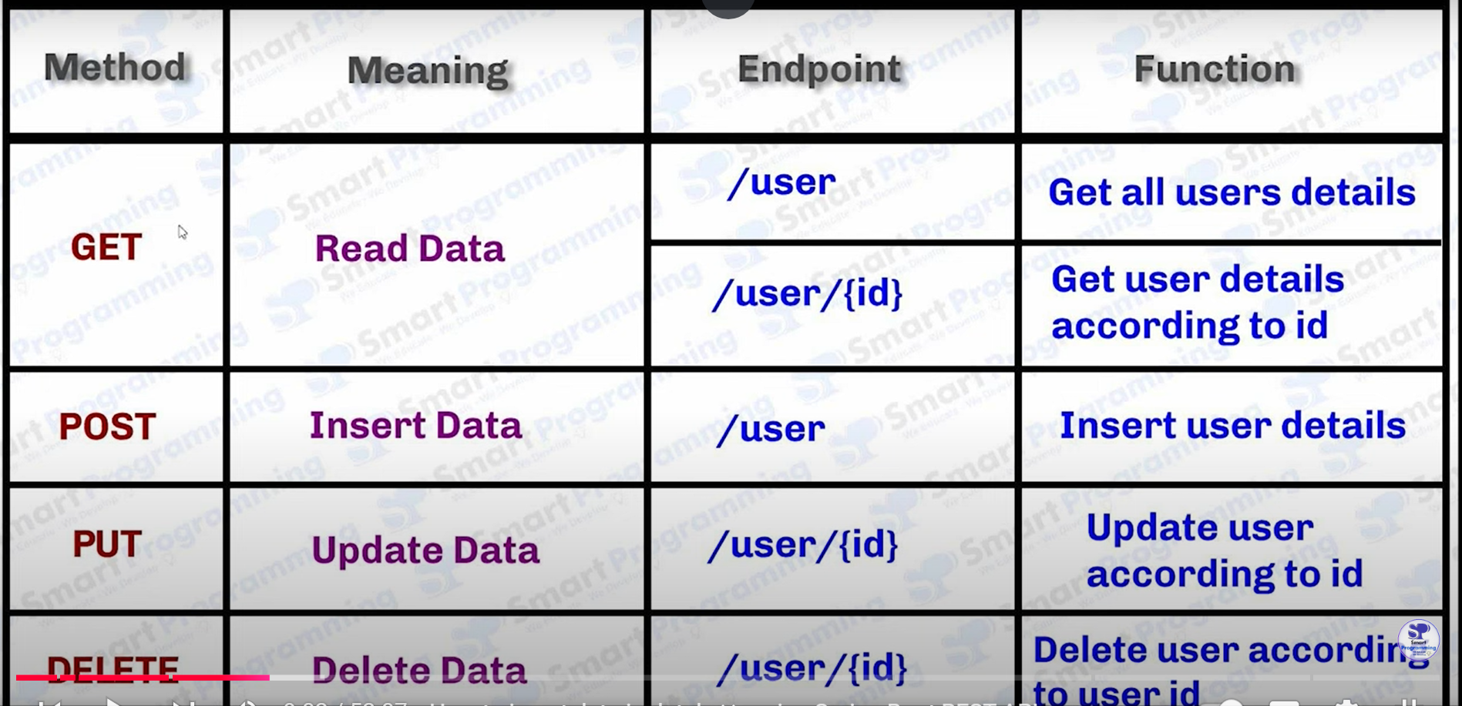

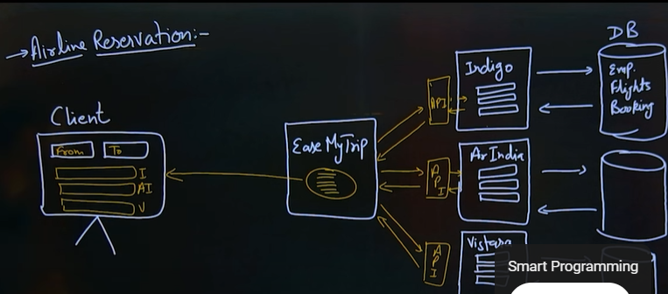**Another example🡪Airline Reservation Json part is very IMP**

**What is Rest(Representational State transfer) ?**

**What is restful?**

**API vs Web Service**

**Which terminology is correct**

**1.restful API or rest API**

**2.Rest web service or restful web service**

**Architectural style🡪its define how multiple systems should communicate each other**

**It outlines the principle and patterns for data exchange within multiple systems**

**E.g. Rest (Representational state transfer)**

**SOAP(Simple object Access Protocol)**

**GRAPHQL**

**RPC(remote procedure call)**

**Rest(Representational state transfer) rest is only conceptual part**

**This is an architectural style having 6 constraints should follow**

1. **Client-Server🡪separation concerns between server and clients**
2. **Stateless 🡪 Each request from client to the server must contain all information needed to understand and process the request**
3. **Cacheable🡪 responses should define whether they can cached or not**
4. **Uniform interface🡪for interacting with resources using http method like get post put delete**
5. **Layered system 🡪client don’t need to know whether they are connected to the server or through an intermediary(e.g. Load balancer or proxy)**
6. **Code on demand🡪 server can provide executable code to client when needed(e.g. JavaScript)**

**Definition rest🡪 rest is theoretical or conceptual part**

**Representational- how it should represent the data or object(xml,json)**

**State-current information**

**Transfer -how data is transferred I.e using HTTP method i.e. get ,post etc**

**Restful :Api coding**

* + It is the actual API or webservices which follows the **restConstraints**

**API vs webservices(its also API)**

* + **API can exchange data in various format ,Json, xml, html, image**
  + **Web services exchange data are mostly in Json and xml format**

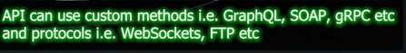

* + Web service It uses only http methods get post

**In Spring Boot use🡪 restful web service**

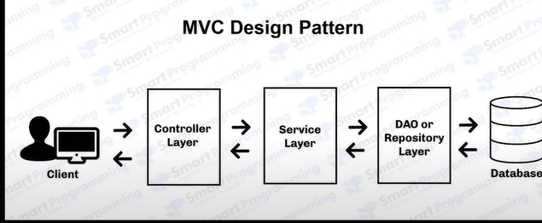**How to create restful web services in spring boot**

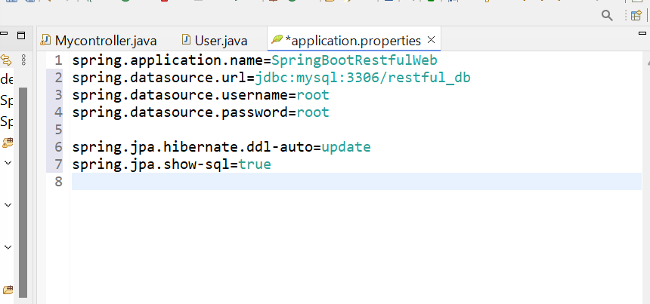

**Spring.jpa.hibernate.ddl-auto=update // this query create table**

**Spring.jpa.show-sql=true // its showing database data**

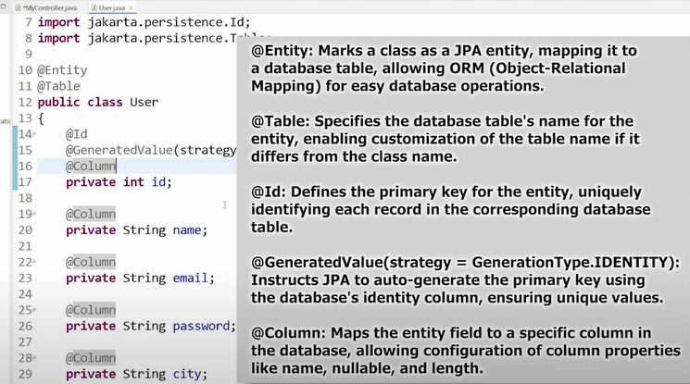



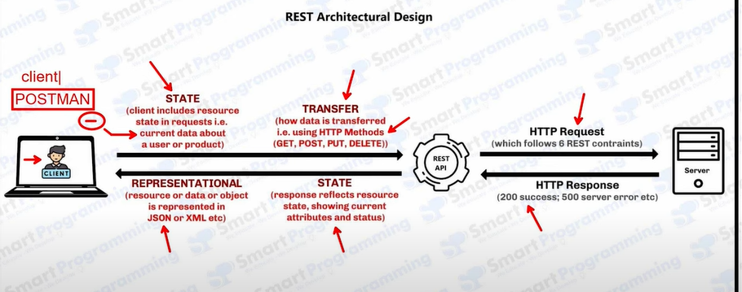

**POSTMAN**

Postman is powerful API client tool used for testing and interacting with APIS it simplify sending the request inspecting responses and automating API workflow enhancing development and debugging efficiency

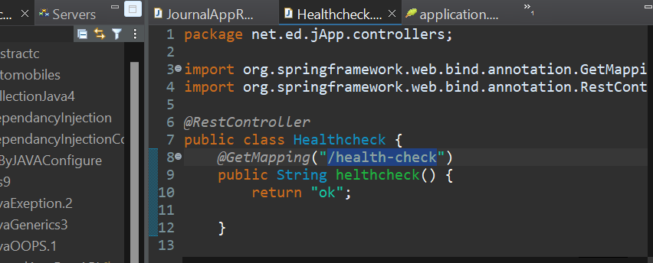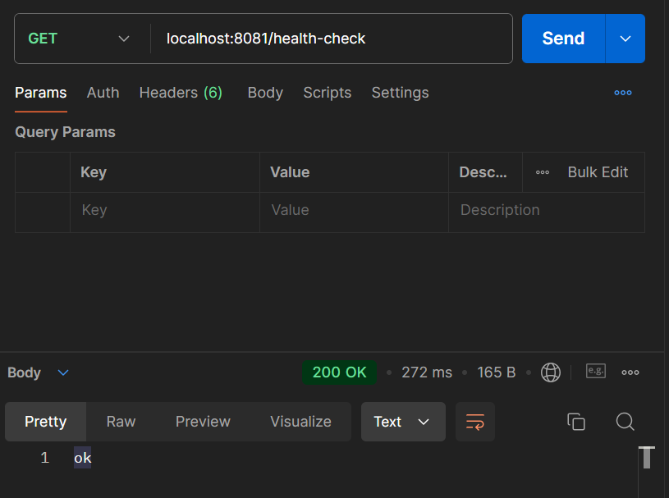Example make App🡪

